Time Series Data Analytics: Bitcoin Price and Volatility Forecasting
Project by
Meaghan Ryan

Saint Mary’s University’s Sobey School of Business

May 2026, Halifax, Nova Scotia

Date: May 10th, 2026

Introduction
This project analyzes Bitcoin price behaviour, return dynamics, and volatility patterns using applied time-series methods. The analysis begins by organizing the Bitcoin dataset chronologically and constructing key financial variables, including closing price ratios, daily log returns, and daily log volume growth. It then evaluates stationarity, compares moving-average and exponential-smoothing forecasting methods, examines ACF and PACF patterns in log returns, and fits an AR(1) model to assess whether past returns contain useful predictive information. The project also uses squared returns as a volatility proxy to investigate volatility clustering and the possible relevance of ARCH/GARCH-type modelling. In all, this work demonstrates how financial analytics can move from raw cryptocurrency market data to practical insight about forecasting, market efficiency, and time-varying risk.

Question One
- The Bitcoin dataset was imported into Excel and arranged in chronological order from the earliest observation to the most recent observation.
- The following variables were constructed from the dataset: closing price P_{t}/P_{t-1}) and daily log volume growth g_{t} = 100 * ln(V_{t}/V_{t-1}).
- Bitcoin Volumes by Date

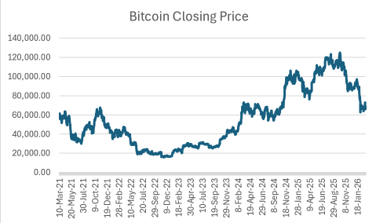
Figure 1(c1). Bitcoin closing prices by date. Series shows substantial changes in level over time.

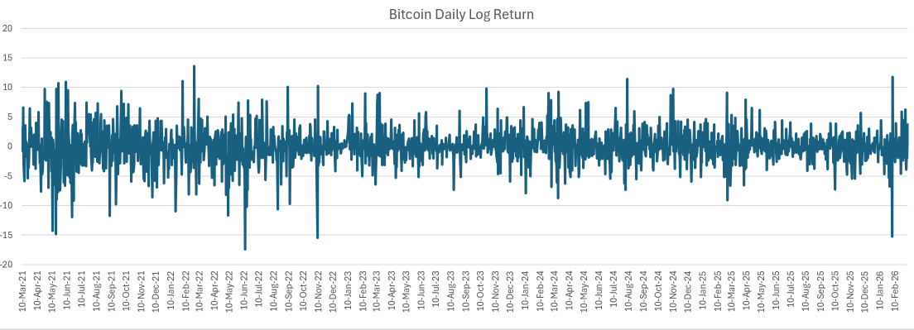
Figure 1(c2). Bitcoin daily log return by date. The return series fluctuates around zero with changing volatility.

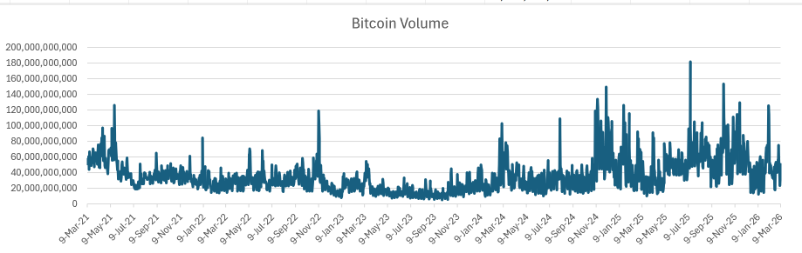

Figure 1(c3). Bitcoin trading volumes by date. Trading volume varies considerably and includes several pronounced spikes.

- The Bitcoin closing price series in Figure 1(c1) appears non-stationary because it does not fluctuate around a constant mean and instead displays substantial level shifts over time.

By contrast, the daily log return series in Figure 1(c2) is much closer to stationary, fluctuating around zero and there is no persistent trend. However, the size of return fluctuations changes across the sample, which indicates that the volatility isn’t constant throughout time. In Figure 1(c3), the trading volume changes quite a bit as well and has several pronounced spikes. In all, the plots suggest that the prices are non-stationary, the returns are nearly stationary, and there is volatility varying with time.

Question Two
- The forecasts were constructed using a 5-day moving average and a 20-day moving average based on Bitcoin closing price series.
- Simple exponential smoothing forecasts were constructed using ⍺ = 0.2 and ⍺ = 0.8, with the initial forecast set equal to the first observed closing price.
- The last 20% of observations were used as the test set. Forecast performance was compared using CFE, MSE, MAD, and MAPE. This is viewable in Figure 2. Among the four forecasting methods, SES(0.8) performed the best because it produced the lowest MSE, MAD, and MAPE on the test sample. Economically, this suggests Bitcoin closing prices are better forecast using a method that places relatively high weight on recent observations. Basically, a more responsive forecasting model performs well because Bitcoin prices can change quickly, and older information can become less relevant in a brief timespan.

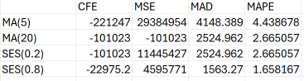
Figure 2 Forecast performance comparison across MA(5), MA(20), SES(0.2), and SES(0.8). This suggests Bitcoin price dynamics are better captured by a method that adjusts quickly to recent market movements rather than one with the tendency to smooth heavily over longer windows.
Question Three
- The autocorrelation function (ACF) of the daily log return series was examined up to Lag 20.
- Based on the ACF values, the daily log return process appears close to white noise, seeing as autocorrelations are generally small and fluctuate around zero rather than displaying a strong persistent pattern.
- The ACF does not suggest strong AR or MA structure in the conditional mean of Bitcoin daily log returns. At most, there might be weak dependence at a few isolated lags, but the general pattern is much more consistent with near white noise than with a strongly autoregressive or moving-average process. This implies that past daily returns provide limited linear predictive information about future daily returns. By contrast, the Bitcoin price series itself is non-stationary because it contains substantial level shifts and long-run movements throughout time. The return series is much closer to stationary because transforming prices into returns removes much of that persistence and centres the series around zero.
- PACF examination would be expected to show the same general conclusion: there is no strong low-order partial autocorrelation pattern suggesting a dominant AR process. Taken together, the evidence point toward daily Bitcoin returns behaving approximately like white noise in the conditional mean.
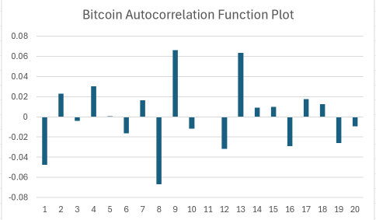
Figure 3(a). The ACF of Bitcoin log returns up to Lag 20.

I did this project with Excel, running the PACS with the add-on, Data Analysis. It only allows for up to 16 lags. I then did the remaining four lags by using the regular Y2025_Assignment3_BitcoinPriceD tab and the coefficients for the Excel calculated formulas.
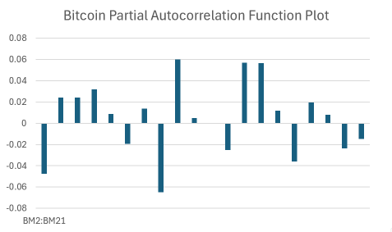
Figure 3(b). PACS plot for Bitcoin log returns up to Lag 20.

The ACF and PACF values are generally small in magnitude and fluctuate around zero. This suggests limited linear dependence across lags in Bitcoin daily log returns. At most,
Question Four
- An AR(1) model was fitted to the Bitcoin log return series using the training sample.

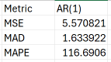
Figure 4a. AR(1) test sample forecast error metrics for Bitcoin log returns.
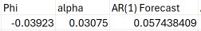
Figure 4b. displays Estimated AR(1) coefficient, intercept, and first one-step-ahead forecast for Bitcoin log returns.

The estimated coefficient was small (ϕ = -0.03923) which suggests only weak linear dependence on daily Bitcoin returns. This is consistent with the ACF and PACF results from Question Three, which indicated that the conditional mean of returns is close to near white noise. The test-sample forecast errors from the AR(1) model were MSE = 5.570821, MAD = 1.633922, and MAPE = 116.6906. Because this model forecasts returns rather than prices, these metrics are not directly comparable to the price-level forecast metrics from Question Two. Economically, the results suggest that past daily Bitcoin returns provide only limited linear predictive information about future daily returns.
Question Five
- Volatility proxy was defined using squared returns: VP_{t} = r_{t}².

- The return and squared-return plots indicate periods of relative calm movement followed by periods of elevated fluctuation. This pattern is consistent with volatility clustering, since large movements tend to be followed by further large movements and quieter periods tend to be followed by relatively small movements.

- The ACF of squared returns is more informative than the ACF of raw returns for detecting persistence in volatility. While the return series itself appears close to white noise in the conditional mean, the squared-return series suggests more persistence, which is consistent with time-varying conditional variance.

- This regression was estimated to examine whether volatility depends on lagged volatility:
r_{t}² = γ₀ + γ1r²_{t-1} + u_{t}

A positive and statistically significant meaningful estimate of γ1 would indicate volatility clustering because it would imply that larger squared returns tend to be followed by larger squared returns.

- This regression was estimated to examine whether volatility is associated with trading volume growth and the magnitude of the previous return:

r2_{t} = δ₀ + δ₁g_{t} + δ₂|r_{t−1}|+ ε_{t}

If δ₁ and/or δ₂ are positive, this suggests that volatility rises when trading activity increases and when the previous day’s return has a larger absolute size. Taken together with the evidence of volatility clustering, this would support the view a GARCH model is appropriate for Bitcoin returns.

In all, the evidence is consistent with ARCH/GARCH-type behaviour in Bitcoin returns. In economic terms, this means past volatility appears to carry information about future volatility even though past returns provide only limited linear predictive information about future returns.

